**JAVASCRIPT**

1. What is JavaScript. How to use it?

* Javascript is a powerful programming language that is primarily used to create dynamic and interactive content on web pages.

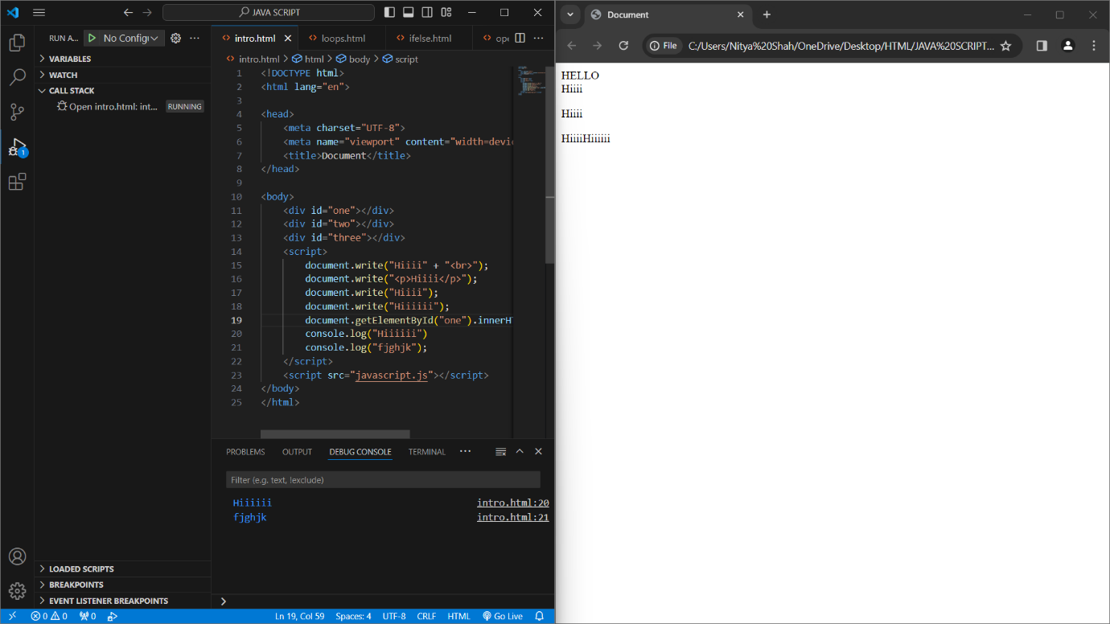

1. How many type of Variable in JavaScript?

* Basically there are three types of variables in js:

1. let
2. var
3. const
4. Define a Data Types in js?

* In javascript, data types refer to the different kinds of values that can be used and manipulated in the language.

1. What the deference between undefined and undeclare in JavaScript?

* A variable is said to be undefined when if it is declared in the code but has not been assigned a value, whereas it is undeclared if it has not been declared at all in the code.

6. Using console.log() print out the following statement: The quote 'There is no exercise better for the heart than reaching down and lifting people up.' by John Holmes teaches us to help one another.

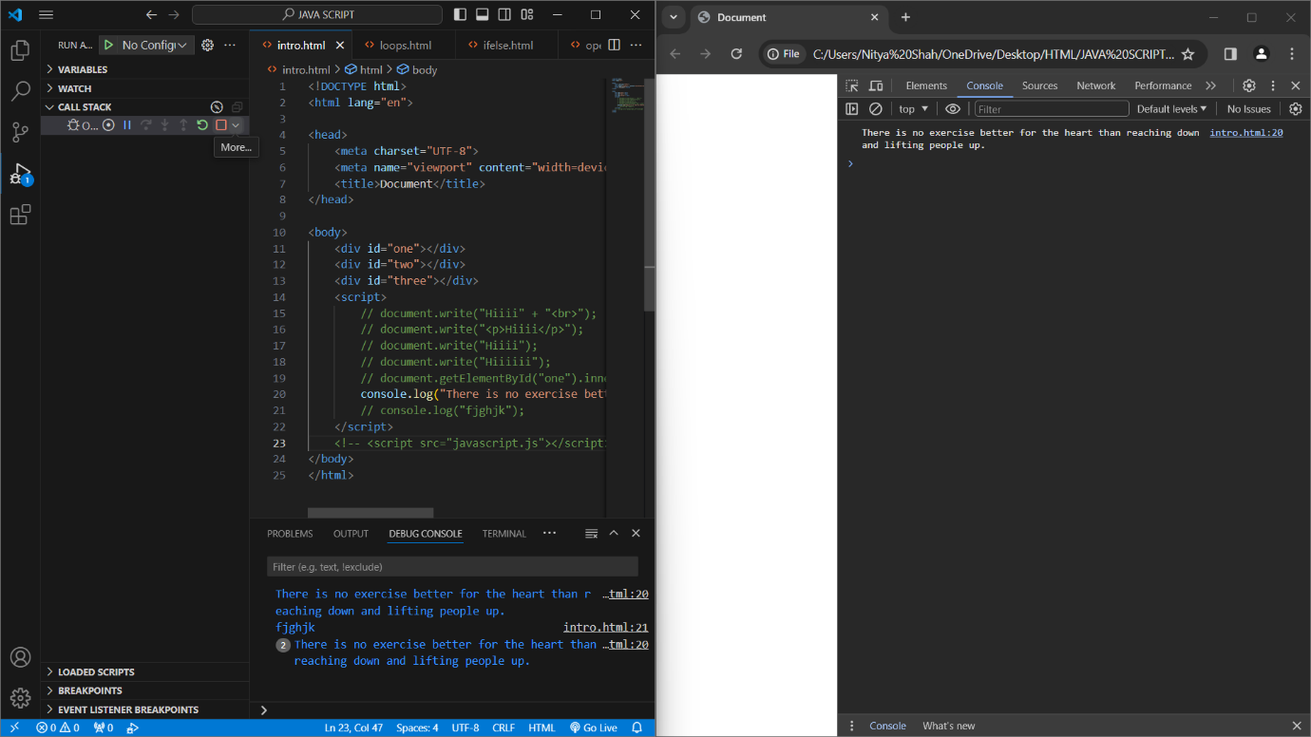

1. Check if type of '10' is exactly equal to 10. If not make it exactly equal?

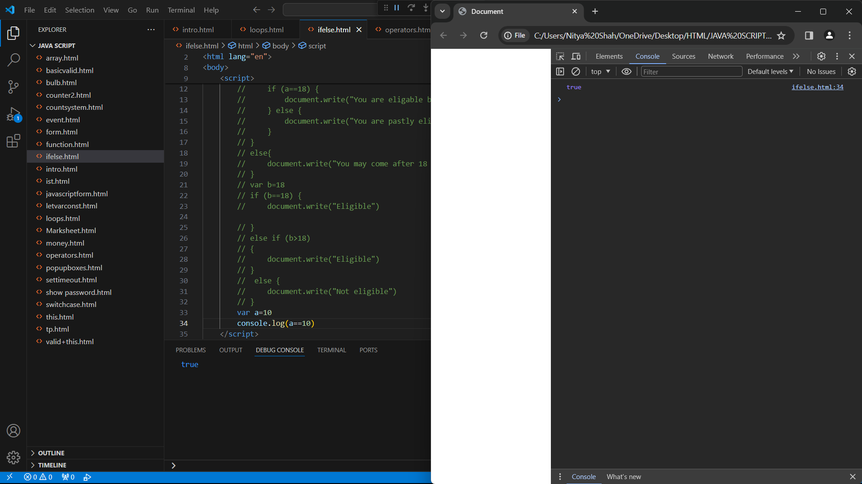

1. Write a JavaScript Program to find the area of a triangle?

* Uploaded on Github.

1. Write a JavaScript program to calculate days left until next Christmas?

* Uploaded on Github.

1. What is Condition Statement?

* Conditional statements in programming are used to control the flow of a program based on certain condition.

1. Find circumference of Rectangle formula : C = 4 * a ?

* Uploaded on Github.

1. WAP to convert years into days and days into years?

* Uploaded on Github.

1. Convert temperature Fahrenheit to Celsius?

* Uploaded on Github.

1. Write a JavaScript exercise to get the extension of a filename.?

* Uploaded on Github.

1. What is the result of the expression (5 > 3 && 2 < 4)?

* True.

1. What is the result of the expression (true && 1 && "hello")?

* hello.

1. What is the result of the expression true && false || false && true?

* false.

1. What is a Loop and Switch Case in JavaScript define that ?

* Loop aloows you to execute a block of code repeatedly till the condition is true while switch case allows to execute a particular code from no. of available codes by matching the case or executing the default statements if there is no match.

1. What is the use of is Nan function?

* The primary purpose of is Nan is to check if the given value is a valid number or not.

1. What is the difference between && and || in JavaScript?

* The logical AND (&&) operator returns true if both the operands are true whereas logical OR (||) returns true even if any one operand is true.

1. What is the use of Void (0)?

* The void operator evaluates an expression and returns undefined. By running void(0) in the URL Javascript code, nothing is evaluated or returned.

1. Check Number Is Positive or Negative in JavaScript?

* Uploaded on Github.

1. Find the Character Is Vowel or Not ?

* Uploaded on Github.

1. Write to check whether a number is negative, positive or zero?

* Uploaded on Github.

1. Write to find number is even or odd using ternary operator in JS?

* Uploaded on Github.

1. Write find maximum number among 3 numbers using ternary operator in JS.

* Uploaded on Github.

1. Write to find the largest of three numbers in JS?

* Uploaded on Github.

1. Write to show

i. Monday to Sunday using switch case in JS?

ii. Vowel or Consonant using switch case in JS?

* Uploaded on Github.

1. What are the looping structures in JavaScript? Any one Example?

* Javascript offers several looping structures to help you execute a block of code repeatedly. Types are:

1. For loop
2. While loop
3. Do…while loop
4. For…in loop
5. For…of loop

Example:

* for(initialization,condition,updation){

code to be executed;

}

1. Write a print 972 to 897 using for loop in JS?

* Uploaded on Github.

1. Write to print factorial of given number?

* Uploaded on Github.

1. Write to print Fibonacci series up to given numbers?

* Uploaded on Github.

1. Write to print number in reverse order e.g.: number = 64728 ---> reverse =82746 in JS?

* Uploaded on Github.

1. Write a program make a summation of given number (E.g., 1523 Ans: - 11) in JS?

* Uploaded on Github.

1. Write a program you have to make a summation of first and last Digit. (E.g., 1234 Ans: - 5) in JS?

* Uploaded on Github.

1. Use console.log() and escape characters to print the following pattern in JS?

1 1 1 1 1

2 1 2 4 8

3 1 3 9 27

4 1 4 16 64

5 1 5 25 125

* Uploaded on Github.

1. Use pattern in console.log in JS?

1)

1

1 0

1 0 1

1 0 1 0

1 0 1 0 1

2)

A

B C

D E F

G H I J

K L M N O

3)

1

2 3

4 5 6

7 8 9 10

11 12 13 14 15

4)

*

* *

* * *

* * * *

* * * * *

* Uploaded on Github.

1. Accept 3 numbers from user using while loop and check each numbers palindrome?

* Uploaded on Github.

1. Write a JavaScript Program to display the current day and time in the following format. Sample Output: Today is Friday. Current Time is 12 PM: 12 : 22 2 ?

* Uploaded on Github.

1. Write a JavaScript program to get the current date?

* Uploaded on Github.

1. Write a JavaScript program to compare two objects?

* Uploaded on Github.

1. Write a JavaScript program to convert an array of objects into CSV string?

* Uploaded on Github.

1. Write a JavaScript program to capitalize first letter of a string?

* Uploaded on Github.

1. Write a JavaScript program to determine if a variable is array?

* Uploaded on Github.

1. Write a JavaScript program to clone an array?

* Uploaded on Github.

1. What is the drawback of declaring methods directly in JavaScript objects?

* Some of the drawbacks of declaring methods in js are as follows:

1. Memory Inefficiency
2. Performance Issues
3. Inheritance Challenges
4. Lack of Shared Scope
5. Print the length of the string on the browser console using console.log()?

* Uploaded on Github.

1. Change all the string characters to capital letters using toUpperCase() method?

* Uploaded on Github.

1. What is the drawback of declaring methods directly in JavaScript objects?

* Some of the drawbacks of declaring methods in js are as follows:

1. Memory Inefficiency
2. Performance Issues
3. Inheritance Challenges
4. Lack of Shared Scope
5. Write a JavaScript program to get the current date. Expected Output : mm-dd-yyyy, mm/dd/yyyy or dd-mm-yyyy, dd/mm/yyyy?

* Uploaded on Github.

1. Use indexOf to determine the position of the first occurrence of a in 30 Days Of JavaScript?

* Uploaded on Github.

1. Use lastIndexOf to determine the position of the last occurrence of a in 30 Days Of JavaScript?

* Uploaded on Github.

1. Form Validtion in JS?

* Uploaded on Github.

1. Form in Email, number, Password, Validation?

* Uploaded on Github.

1. Dynamic Form Validation in JS?

* Uploaded on Github.

1. how many type of JS Event? How to use it ?

* There are 5 types of events:

1. Mouse event.
2. Keyboard event.
3. Window event.
4. Document event.
5. Form event.
6. What is Bom vs Dom in JS?

|  |  |
| --- | --- |
| **BOM** | **DOM** |
| -The BOM is a browser-specific convention that refers to all the objects exposed by the web-browser. It allows JS to interact with the browser itself. | - The DOM is a programming interface for HTML and XML documents. It represents the structure of a document as a tree of objects, where each object corresponds to a part of the document. |
| -It provides methods and properties to interact with the browser window and control browser features.  -Components: window, navigator, screen, history, location, etc. | -It allows JS to access and manipulate the content, structure, and style of a document.  - Components: Elements, attributes, and text within the HTML document. |
| -Common Methods: window.alert(), window.open(),location.href() | -Common Methods: document.getElementById(), document.getElementByClassName() |

1. Array vs Object.

|  |  |
| --- | --- |
| **ARRAY** | **OBJECT** |
| -An array is a collection of elements of same datatype | - It is also a collection of elements but not necessarily of same data type. |
| -It uses [] bracket. | -It uses {} bracket. |

1. Split the string into an array using split() Method?

* Uploaded on Github.

1. Check if the string contains a word Script using includes() method?

* Uploaded on Github.

1. Change all the string characters to lowercase letters using toLowerCase() Method.

* Uploaded on Github.

1. What is Character at index 15 in ’30 Days of JavaScript’ string? Use charAt() method.

* Uploaded on Github.

1. copy to one string to another string in JS?

* Uploaded on Github.

1. Find the length of a string without using libraryFunction?

* Uploaded on Github.

1. What is the use of isNaN function?

* Nan() function is used to determine a value is ‘Not a Number’.

1. What is negative Infinity?

* Represents a value that is less than any other number.

1. Which company developed JavaScript?

* Netscape Communication Corporation.

1. What are undeclared and undefined variables?

* ViewState is to manage state at the client’s end, making state management easy for end-user while SessionState manages state at the server’s end, making it easy to manage content from this end too.

1. What is === operator?

* ===, strict operator is used to compare strings of its operands.

1. What are all the looping structures in JavaScript?

- *Types of loops in js:

1.for loop syntax:

for(statement1;statement2;statement3){

code to be executed

}

2.for in loop syntax:

for(key in object){

Code to be executed

}

3.for of loop syntax:

for(variable of iterable(like arrays & strings)){

code to be executed

}

4.while loop syntax:

while(condition){

code to be executed}

5.do while loop syntax:

do{

code to be executed

}while(condition)

*do while loop will be executed atleast once.

74. How can you convert the string of any base to an integer in JavaScript?

- Using parseInt().

75. What is the use of Void (0)?

- In JavaScript, void(0) is often used to prevent the browser from performing its default action, such as navigating to a new page or refreshing the current page.

76. How can a page be forced to load another page in JavaScript?

- window.location

77. What are the disadvantages of using innerHTML in JavaScript?

- 1. Performance isuue.

2. Security Risks.

3. Content Replacement.

4. Validation Isuues.

*Marksheet

Calculator

Show password

Slider

Uploaded On Github.